

**Kalarang 2024 An Annual Celebration of Artistry and Unity**

Agastya Academy's Kalarang 2024 began as the sun set at around 5:15 PM on January 9th in the Agastya Amphitheatre, featuring Mr. M. Chinnasami, MD of Agni Steels and Founder of Olirum Erode Foundation, as our esteemed Chief Guest. The event, marked by careful preparation and a cooperative spirit, aimed to provide us, a platform to express ourselves through various cultural performances, thereby contributing to our school's ethos of positive change.

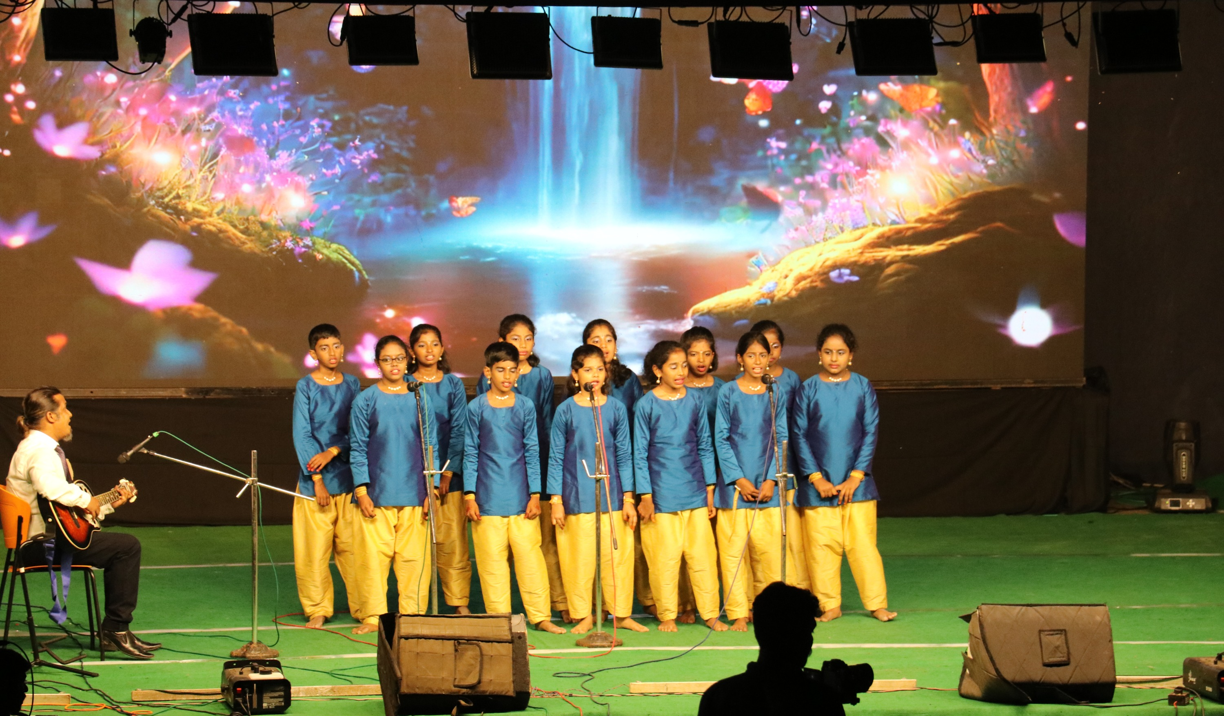

The amphitheatre came alive on January 9th as our parents, relatives, and staff gathered to witness the grand spectacle. The evening began as we played melodious tunes of flutes, setting a captivating tone for the cultural festivities.

[Click here for more.........](https://www.agastyaacademy.edu.in/post/kalarang-2024-an-annual-celebration-of-artistry-and-unity)